SIMATS ENGINEERING
ASSESSMENT TOOL 2: Scenario-Based Research Assessment
COURSE NAME: ARTIFICIAL INTELLIGENCE COURSE CODE: MLA01
AND EXPERT SYSTEMS

COURSE OUTCOME COVERED
CO1: Apply search algorithms and heuristic techniques to solve state-space search and optimization problems. (BTL 3)
Assessment Tool Weightage: 45 %

Total Marks: 50 Time: 60 Mins
No. of Questions: 5
Annexure A
Scenario-Based Research Assessment

Code of Conduct:

I P Dinesh Reddy / 192525399 (Name / Reg No) certify that this submission is my original work and that I have adhered to the guidelines specified for this assessment. I understand that any violation of academic integrity rules will result in disciplinary action.

Signature of the student:

Criterion | Weightage | Marks Obtained
Identification of Latest AI Application | 10%
Problem Analysis and Domain Understanding | 15%
AI Technologies and Working Mechanism | 20%
Research Quality and Literature Review | 10%
Real-World Implementation and Case Analysis | 10%
Impact, Challenges, and Future Scope | 15%
Originality and Critical Thinking | 10%
Organization, Presentation, and Documentation | 10%
Total | 100%
Signature of the Faculty Total Marks Awarded
ANSWER ANY ONE

No. | AI Domain | Scenario-Based Research Question
1 | Healthcare | Healthcare organizations are increasingly adopting Artificial Intelligence to improve diagnosis, treatment, and patient monitoring. Identify and research a latest AI-based application in healthcare (such as AI-assisted medical diagnosis, AI radiology systems, robotic surgery, AI drug discovery, or virtual healthcare assistants). Analyze its working principles, AI techniques used, real-world implementation, benefits, and limitations.
2 | Finance | Financial institutions are leveraging Artificial Intelligence to enhance security, decision-making, and customer services. Identify and research a latest AI application in the finance domain (such as AI fraud detection systems, AI-powered financial advisors, algorithmic trading platforms, or intelligent banking assistants). Discuss its functionality, technologies involved, advantages, and challenges.
3 | Retail | Retail companies are adopting AI-driven solutions to provide personalized and intelligent shopping experiences. Identify and research a latest AI application in retail (such as Generative AI shopping assistants, AI recommendation engines, virtual try-on systems, or AI-based demand forecasting). Explain its application, AI methods used, impact on customers and businesses, and future scope.
4 | Autonomous  Vehicles | The transportation sector is rapidly evolving with AI-based autonomous systems. Identify and research a latest AI application in autonomous vehicles (such as self-driving technology, AI-based perception systems, autonomous delivery vehicles, or intelligent traffic management). Analyze the AI technologies involved, real-world deployment, benefits, and challenges.
5 | Robotics | Intelligent robots are being developed for applications in industries, healthcare, education, and daily life. Identify and research a latest AI application in robotics (such as humanoid robots, collaborative robots, service robots, or AI-powered warehouse robots). Explain their capabilities, AI techniques, real-world usage, and future developments.
6 | Manufacturing | Manufacturing industries are integrating AI to achieve smart and automated production environments. Identify and research a latest AI application in smart manufacturing (such as AI-based predictive maintenance, computer vision quality inspection, digital twins, or autonomous manufacturing systems).  Discuss its working, industrial applications, advantages, and limitations.

Structure of the Report:

S.No |  | Report Component | Student Deliverable / Guiding Question
 | 1 | Title of AI Application | Provide the name of the latest AI application selected and the corresponding AI domain.
 | 2 | Domain Selection | Identify the application domain (Healthcare / Finance /  Retail / Autonomous Vehicles / Robotics / Manufacturing).
 | 3 | Introduction and Background | Describe the AI application and provide an overview of its purpose and importance.
 | 4 | Problem Identification | Explain the real-world problem or challenge addressed by this AI application.
 | 5 | Need for AI Solution | Analyze why AI is required and how it improves traditional approaches.
 | 6 | AI Technologies Used | Identify the AI techniques involved (Machine Learning, Deep Learning, NLP, Computer Vision, Generative AI, Robotics, etc.).
 | 7 | Working Mechanism | Explain how the AI system works, including input data, processing methods, decision-making, and output generation.
 | 8 | Data Sources and Processing | Describe the type of data used and how the data is processed for intelligent decision-making.
 | 9 | Real-World Implementation | Identify organizations, industries, or real-world scenarios where this AI application is currently implemented.
 | 10 | Impact and Benefits | Evaluate the improvements achieved through the AI application in terms of efficiency, accuracy, cost, user experience, or automation.
 | 11 | Challenges and Limitations | Discuss technical, ethical, privacy, security, and deployment challenges associated with the application.
 | 12 | Future Scope and Emerging  Trends | Explain possible enhancements, future developments, and research opportunities in this AI application.
 | 13 | Conclusion | Summarize the significance of the AI application and its contribution to solving real-world problems.
 | 14 | References | Provide research papers, technical articles, industry reports, and reliable sources referred for the study.

AI Radiology Systems: Transforming Medical Imaging Through Artificial Intelligence
Domain :Healthcare
AI Application :AI Radiology Systems

Introduction and Background
Medical imaging is an important part of healthcare because it helps doctors diagnose many diseases at an early stage. Radiologists use imaging techniques such as X-rays, CT scans, MRI scans, and ultrasound scans to examine different parts of the human body. However, analyzing a large number of medical images manually can be time-consuming and may increase the chances of missing small abnormalities.
AI radiology systems are developed to assist radiologists by analyzing medical images using artificial intelligence. These systems help identify possible diseases, highlight abnormal areas, and support doctors during diagnosis. Today, AI radiology systems are being adopted in many hospitals and diagnostic centers to improve diagnostic accuracy, reduce reporting time, and provide better patient care.
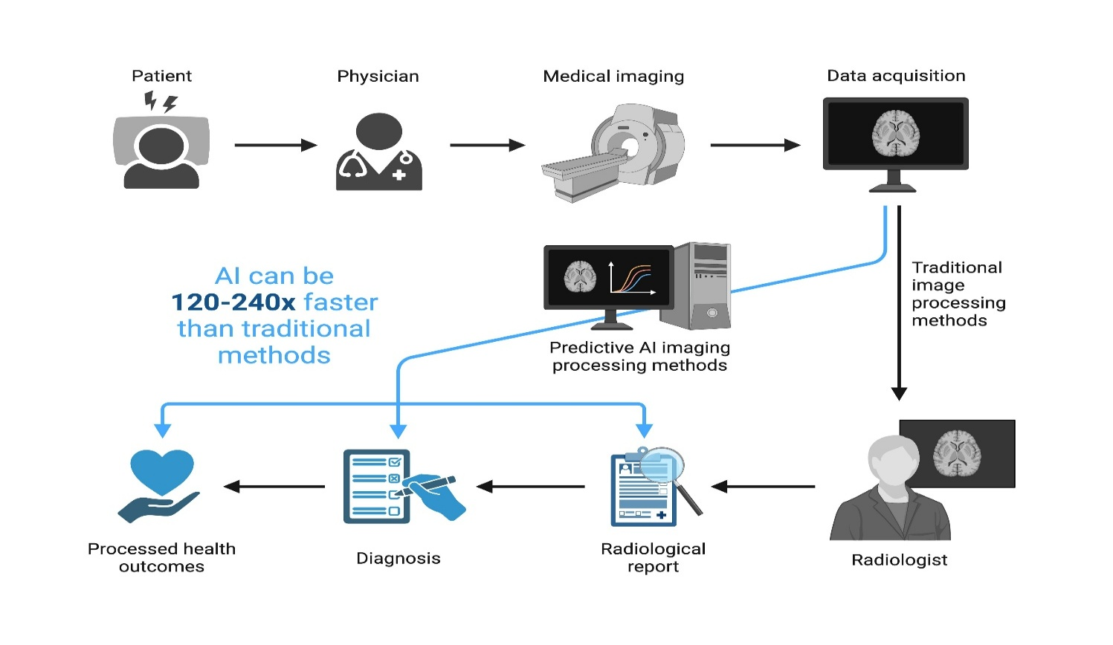
AI Radiology System Workflow
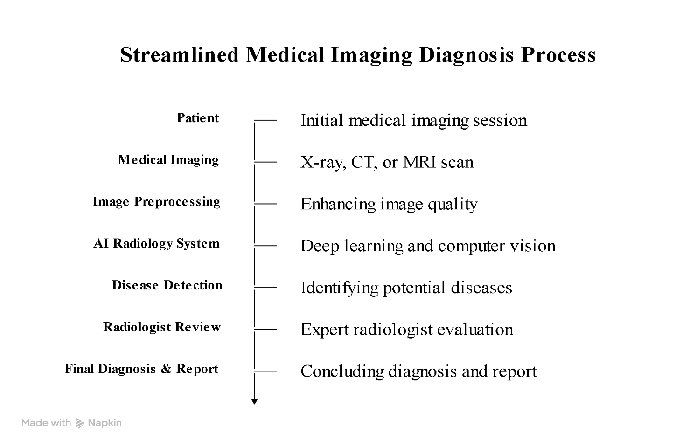
Problem Identification
Medical imaging is widely used to diagnose diseases, but the increasing number of patients has made image analysis more challenging for radiologists. Examining hundreds of X-rays, CT scans, and MRI scans every day requires significant time and attention. In some cases, small abnormalities may be difficult to detect, especially during heavy workloads.
Delayed or inaccurate diagnosis can affect treatment decisions and patient outcomes. Hospitals in many regions also face a shortage of experienced radiologists, making it difficult to provide timely reports. AI radiology systems address these problems by assisting radiologists in analyzing medical images, identifying suspicious areas, and supporting faster and more accurate diagnosis.
Need for AI Solution
The growing number of medical imaging examinations has increased the workload of radiologists. Manual analysis of X-rays, CT scans, and MRI scans requires time and careful attention, especially when dealing with complex cases. This can sometimes lead to delays in diagnosis and increase the risk of human error.AI provides a practical solution by analyzing medical images quickly and identifying patterns that may indicate disease. It helps radiologists detect abnormalities more efficiently, prioritize urgent cases, and improve diagnostic accuracy. AI is not intended to replace medical professionals but to support them in making faster and more informed clinical decisions.
AI Technologies Used
AI radiology systems use a combination of artificial intelligence techniques to analyze medical images and assist in disease detection. The main technologies used are:
Machine Learning (ML): Learns patterns from medical image datasets and improves prediction accuracy over time.
Deep Learning (DL): Uses multi-layer neural networks to identify complex features in X-rays, CT scans, and MRI scans.
Convolutional Neural Networks (CNNs): A deep learning model specially designed for image analysis. CNNs automatically detect important features such as tumors, fractures, or infected regions.
Computer Vision: Enables the system to process, interpret, and analyze medical images for identifying abnormalities.
These technologies work together to help radiologists detect diseases more accurately and reduce the time required for image analysis.
Working Mechanism
The working process of an AI radiology system begins with collecting medical images such as X-rays, CT scans, or MRI scans. These images are first preprocessed to improve their quality by removing noise and adjusting brightness or contrast.
The processed images are then analyzed using deep learning models, especially Convolutional Neural Networks (CNNs). The AI model identifies important features and compares them with patterns learned during training to detect possible abnormalities, such as tumors, fractures, or lung infections.

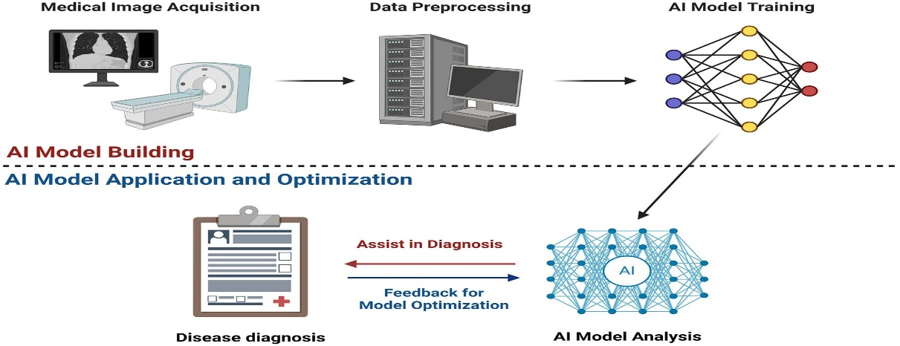
Working Mechanism of an AI Radiology System
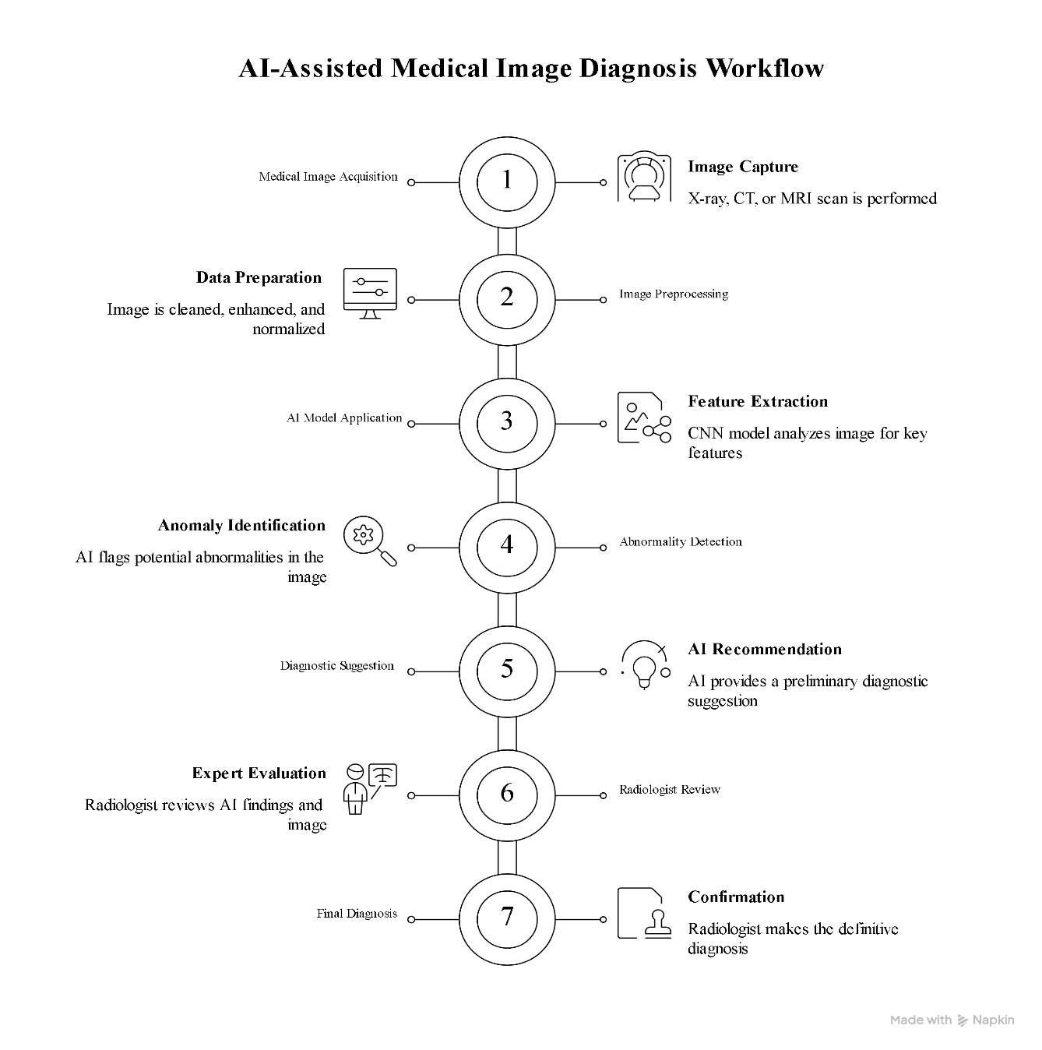

Data Sources and Processing

AI radiology systems are trained using large datasets of medical images collected from hospitals, diagnostic centers, and publicly available medical databases. These datasets include X-rays, CT scans, MRI scans, and ultrasound images, along with reports prepared by experienced radiologists.
Before analysis, the images are preprocessed to improve their quality. This includes removing noise, adjusting image size, and enhancing contrast. The processed images are then used to train AI models to recognize normal and abnormal patterns. During diagnosis, the AI system compares new medical images with the patterns it has learned and provides results that assist radiologists in making accurate clinical decisions.
Real-World Implementation

AI radiology systems are being used in many hospitals and diagnostic centers to support medical image analysis. They assist radiologists in detecting diseases such as lung cancer, pneumonia, tuberculosis, brain tumors, and bone fractures from X-rays, CT scans, and MRI scans.

Several healthcare technology companies have developed AI-based radiology solutions that help doctors identify abnormalities more quickly and accurately. These systems are also used in emergency departments to prioritize critical cases, allowing patients with serious conditions to receive timely medical attention. By supporting faster diagnosis and reducing the workload of radiologists, AI radiology systems have become an important part of modern healthcare.

Applications of AI Radiology Systems
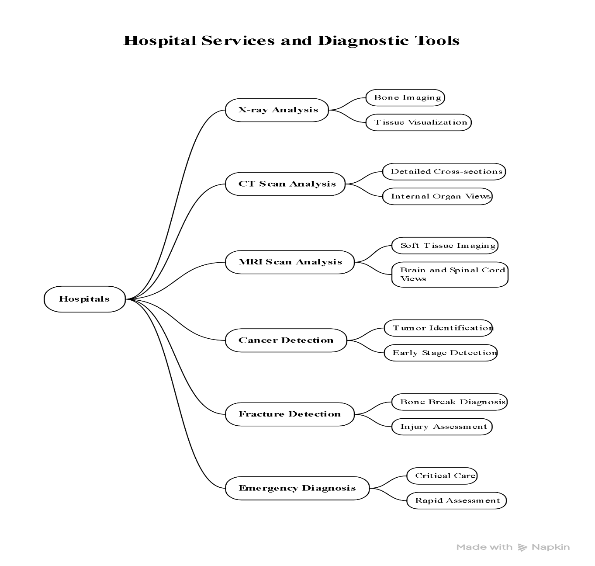

Impact and Benefits
AI radiology systems have improved the quality and efficiency of medical image analysis. They help radiologists detect diseases at an early stage by identifying abnormalities that may be difficult to notice during manual examination. This improves diagnostic accuracy and supports timely treatment.
These systems also reduce the time required to analyze medical images, allowing hospitals to manage a larger number of patients efficiently. By assisting radiologists with routine image analysis, AI reduces workload and helps doctors focus on complex cases. Overall, AI radiology systems contribute to better patient care, faster diagnosis, and improved healthcare services.
Challenges and Limitations
Despite its advantages, AI radiology systems have several limitations. Their performance depends on the quality and quantity of the medical images used for training. Poor-quality or limited data can affect the accuracy of the results.
Future Scope and Emerging Trends
The use of AI in radiology is expected to increase as technology continues to develop. Future AI systems are likely to provide more accurate image analysis, detect diseases at an earlier stage, and support personalized treatment plans. Improvements in deep learning models and access to larger medical datasets will further enhance their performance.
In the coming years, AI radiology systems are expected to be integrated with electronic health records and other hospital systems to support faster clinical decision-making. Researchers are also working on developing AI models that can identify multiple diseases from a single medical image, making healthcare services more efficient and reliable.
Conclusion
AI radiology systems have become an important tool in modern healthcare by assisting radiologists in analyzing medical images quickly and accurately. They help improve disease detection, reduce reporting time, and support better clinical decision-making. Although challenges such as data quality, implementation costs, and patient privacy still exist, AI continues to improve with ongoing research and technological advancements.
Overall, AI radiology systems support healthcare professionals rather than replace them. Their continued development is expected to enhance medical imaging services and contribute to better patient care in the future.
Rubrics for Evaluation
S.No | Criteria | Weightage  (%) | Excellent (100–90%) | Good (89–75%) | Satisfactory  (74–60%) | Improvement
1. | Identification of  Latest AI  Application | 10% | Selects a highly relevant, emerging AI application with strong justification. | Selects a recent and relevant AI application. | Selects a suitable application with limited justification. | Application is outdated or irrelevant.
2. | Problem Analysis and Domain Understanding | 15% | Clearly explains the real-world problem, domain context, and need for AI with critical analysis. | Good explanation with adequate analysis. | Basic explanation with limited analysis. | Problem statement is unclear or incomplete.
3. | AI Technologies and Working Mechanism | 20% | Accurately explains AI techniques, algorithms, architecture, and workflow with technical depth. | Good explanation with minor omissions. | Covers only basic AI concepts. | AI technologies are poorly explained or incorrect.
4. | Research Quality and Literature  Review | 10% | Uses recent, credible sources with proper citations and excellent synthesis. | Good  quality references with appropriate citations. | Limited references with basic discussion. | Few or unreliable references; poor citation.
5. | Real-World Implementation and Case Analysis | 10% | Thoroughly analyzes industrial implementation with appropriate examples. | Good implementat ion analysis. | Basic implementation discussion. | Minimal or no real-world analysis.
6. | Impact,  Challenges, and  Future Scope | 15% | Critically evaluates benefits, limitations, ethical issues, and future trends. | Good  evaluation with minor gaps. | Basic discussion of impact and future scope. | Limited evaluation or missing sections.
7. | Originality and  Critical Thinking | 10% | Demonstrates independent research, innovation, and critical evaluation. | Good  analytical thinking. | Some originality with limited analysis. | Mostly descriptive or copied content.
8. | Organization,  Presentation, and  Documentation | 10% | Exceptionally organized, professional presentation, error-free, and properly referenced. | Well organized with minor issues. | Adequately organized with some errors. | Poor organization and documentation.

